**Retail Sales Data Analysis: Findings and Recommendations**

**1. Introduction**

This report provides an in-depth analysis of retail sales data, focusing on customer segmentation, sales trends, and product category performance. The aim is to identify key patterns and provide actionable recommendations to optimize business strategies and enhance sales performance.

**2. RFM Analysis and Customer Segmentation**

**Findings:**

* **Customer Segmentation:**
  + **New Customers:** 185 customers
  + **At-Risk Customers:** 89 customers
  + **High-Value Customers:** 89 customers
* **Customer Behavior:**
  + **Recency:** The average recency score across all customers is 315. A recency score of less than 200 indicates customers who are more likely to return soon, while scores above 400 suggest customers who have not made purchases recently.
  + **Frequency:** All customers have a frequency score of 1, indicating that most customers are one-time buyers.
  + **Monetary:** The monetary scores vary significantly, with high-value customers spending considerably more compared to new or at-risk customers.

**Recommendations:**

* **Retain High-Value Customers:** Implement loyalty programs, personalized offers, and exclusive deals to retain high-value customers and encourage repeat purchases.
* **Re-engage At-Risk Customers:** Use targeted marketing campaigns to re-engage at-risk customers, offering discounts or reminders to encourage them to return.
* **Nurture New Customers:** Focus on converting new customers into loyal, repeat buyers by providing excellent customer service, follow-up communication, and incentives for future purchases.

**3. Monthly and Yearly Sales Trends**

**Monthly Sales Trends (First Graph):**

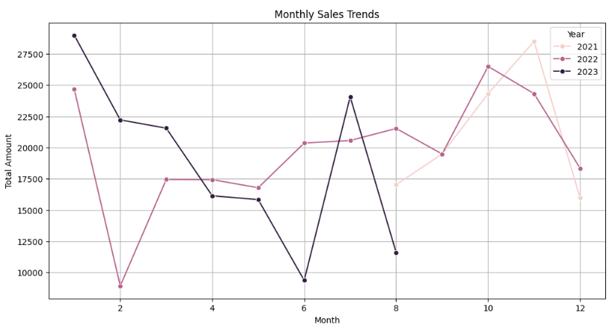  
*Observation of Trend:* The graph displays monthly sales trends for the years 2021, 2022, and 2023. We observe fluctuations in sales over the months for each year, with notable peaks and dips.

**Key Points:**

* **2021:** Sales peaked in January, then dropped sharply in February, followed by fluctuations throughout the year, ending with a slight increase in the final months.
* **2022:** Sales remained relatively stable between January and August, showing a gradual increase from mid-year with a peak in October and November.
* **2023:** The sales trend in 2023 starts high in January, decreases in mid-year, and then rises again towards the end, though not reaching the same peaks as 2022.

**Insights:**

* Sales patterns vary considerably between years, with 2021 having the most volatile fluctuations, while 2022 and 2023 show more stable trends with fewer sharp drops.
* The second half of each year typically shows an upward trend, especially in 2022 and 2023.

**Yearly Sales Trends (Second Graph):**

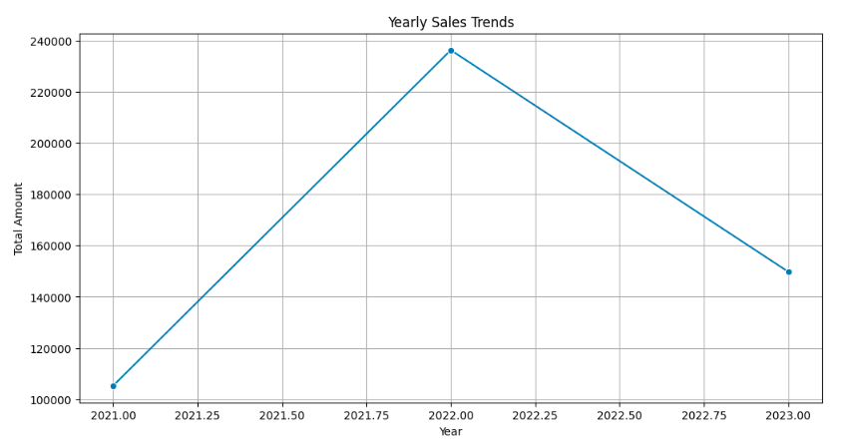  
*Observation of Trend:* The yearly sales trends graph shows a clear rise and fall pattern in sales across three years (2021-2023).

**Key Points:**

* Sales increased steadily from 2021 to 2022, reaching a peak in 2022.
* However, there was a significant drop in total sales in 2023 compared to 2022.
* Overall, sales in 2023 are still higher than those in 2021.

**Insights:**

* The upward growth from 2021 to 2022 indicates positive sales momentum, possibly due to successful strategies or market conditions in 2022.
* The drop in 2023 suggests challenges or changes that impacted sales negatively, which may require further investigation.

These findings indicate a strong year in 2022 for the company but also suggest the need to assess what caused the sales decline in 2023 and to strategize to recover this loss in the upcoming years.

**4. Product Category Performance**

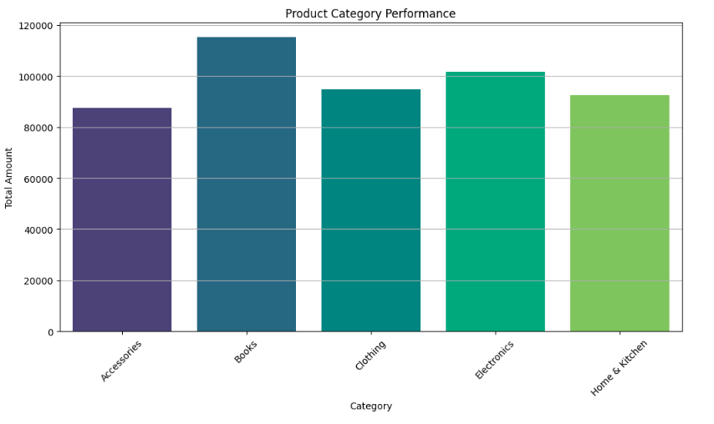

• The bar chart shows the total sales amount for different product categories.

• **Books** have the highest sales performance, closely followed by **Electronics**.

• **Accessories** and **Home & Kitchen** categories have lower sales compared to the others, with Accessories being the lowest among the displayed categories.

**Findings:**

* **Top-Performing Categories:**
  + **Books:** Generated the highest revenue at $115,120.41.
  + **Electronics:** Also performed well, with total sales of $101,544.99.
  + **Clothing:** Generated $94,677.73, making it another significant contributor to overall sales.
* **Other Categories:**
  + **Accessories:** $87,386.95
  + **Home & Kitchen:** $92,568.42

**Recommendations:**

* **Expand Top Categories:** Focus on expanding the inventory and marketing efforts for the top-performing categories (Books, Electronics, Clothing) to capitalize on their success.
* **Cross-Selling Opportunities:** Implement cross-selling strategies by bundling products from different categories, such as Electronics with Accessories, to increase the average transaction value.
* **Explore Growth in Other Categories:** Consider analyzing customer preferences within the Home & Kitchen and Accessories categories to identify opportunities for growth and enhance product offerings.

**5. Sales by Region**

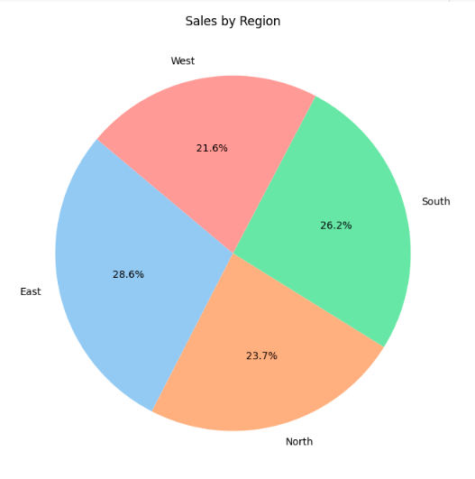

• The pie chart displays the sales distribution by region.

• The **East** region contributes the most to sales, with 28.6% of the total sales.

• The **South** region follows with 26.2%, then **North** with 23.7%.

• The **West** region has the lowest contribution, accounting for 21.6% of the sales.

**Findings:**

* **Regional Sales Distribution:**
  + **East Region:** Highest sales at $140,332.35.
  + **South Region:** $128,528.63
  + **North Region:** $116,418.31
  + **West Region:** Lowest sales at $106,019.21

**Recommendations:**

* **Strengthen Regional Strategies:** Focus on the East and South regions where sales are strong by offering region-specific promotions and expanding distribution channels.
* **Boost Sales in Low-Performing Regions:** Increase marketing efforts in the West region to boost sales, possibly through targeted advertising or localized promotions.
* **Regional Market Analysis:** Conduct a detailed market analysis in the North and West regions to understand customer preferences and tailor product offerings accordingly.

**6. Conclusion**

The retail sales analysis reveals valuable insights into customer behavior, sales trends, and product category performance. By implementing the recommendations provided, the company can enhance customer retention, optimize sales strategies, and drive overall business growth. Regular monitoring and analysis of sales data will be essential to adapting to market changes and ensuring sustained success.